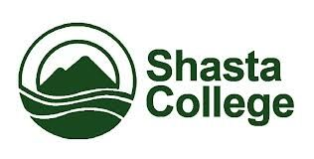
Northern California Adult Education Block Grant Consortium
Public Meeting # 8
11/30/2016 3:00pm-5:00pm

AGENDA ITEMS
- Welcome & Minute Meeting Review
- New Courses Offered - Spring
- Community Pro
- N&R Publications
- Social Media
- Summit Highlights
- Class Updates (RB HS/Corning HS)
- Success Stories
- State Updates
- Action Items

