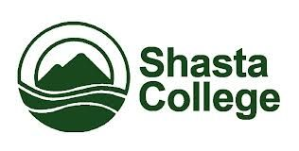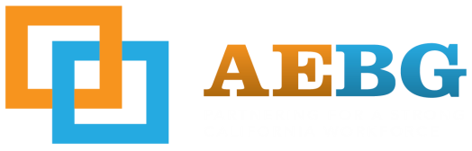
Northern California Adult Education Block Grant Consortium
Public Meeting # 12
Date: 5/18/2017
Time: 3:00pm-5:00pm
Meeting Location: SCOE – Professional Development Center
Trinity Room – 2985 Innsbruck Dr. Redding, CA 96002

AGENDA ITEMS
- New Participants
- Minute Meeting Review
- Voting Items
  - Governing Board members for 17-18 fiscal year
  - 15-16 Budget amendments
  - 16-17 Budget amendments
  - 17-18 Draft Proposal Submissions
  - Website (marketing materials/pricing)
  - Website (logo reveal options)
- Pre-Post Assessment Update
- TOPSpro
  - Data Entry (3Q due 4/30/17)
- Release Forms for data collection
  - Community Pro (objective: integrated reporting and communication to decrease duplication of assessments, forms to be completed by individual receiving services throughout the region.)
    - To be given at intake and when Entry Form is completed
  - Generic Data Reporting release
    - To be given at intake and when Entry Form is completed
- Community Pro
- Performance Update
  - Remaining 15-16 funds and re-allocations
- Updates
  - State
- Success Stories
- Action Items
  - Responding to emails

