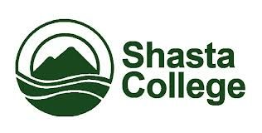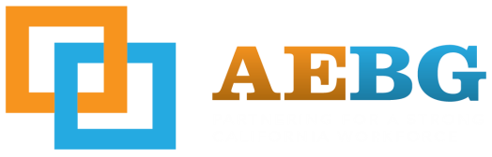
Northern California Adult Education Block Grant Consortium
Public Meeting #2
3/24/2016 3:00pm-5:00pm

Agenda Items
- Welcome and Introductions (10 min)

- Review of Minutes (10 min)

- Review of Progress to Date (30 min)

  - Adult – U Website updates
  - Joining of members – consensus on procedure or permitting of action.

  - Governance Team Review: Proposed 15-16 Budget– Category 1 ABE/GED/ESL (Fiscal Year 15-16 County Allocations for immediate direct local services (direct instruction, materials, supplies, support services and transition/counseling for adult learners)
    - Shasta 146,000
    - Tehama 124,000
    - Trinity 124,000

- Overview of the 16-17 proposed budget (10 min)

- Data Collection (10 min)

- Key Action Items: (30 min)
  - County Sub Group Breakout

- Updates from the State (10 min)

- Hot Topics at next Public Meeting (10 min)

