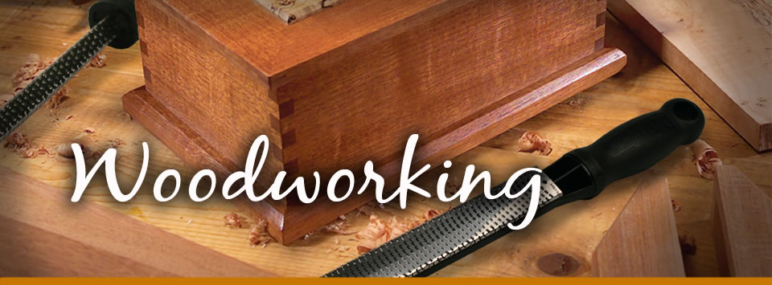

NO charge for attending ~ Material fees may apply

This class is open to ALL levels of experience!

**To Register Contact:**

Ms. Caitlin Canale

707-574-6237 ex. 238

OR email: ccanale@stjusd.org

Todd Perras is our woodshop instructor here at Southern Trinity. He worked for Walt Kowalski Inc. from 1998 to 2009 as head machinist/foreman refining his woodworking skills. With a focus on safety, Todd will teach you the proper use of common woodworking tools and machines and allow you to build your own projects.

Want to learn how to use **woodworking** tools or just want access to a great shop?? With a focus on safety, this class is for you!!

## Date: Tuesdays

2/21 – 4/11/17

**Time:** 2:30 – 4:30 pm

**Place:** STHS Woodshop

# Southern Trinity Adult Education